**MongoDB Replication**

**create data folder inside program files**

create

db0

db1

db2

inside data folder

**//run cmd using run as administrator**

**//for db0**

cd "C:\Program Files\MongoDB\Server\8.0\bin"

mongod.exe --replSet myReplSet --dbpath C:\data\db0 --port 27017 --bind_ip localhost

cd "C:\Program Files\MongoDB\Server\8.0\bin"

mongosh.exe

**//for db1**

cd "C:\Program Files\MongoDB\Server\8.0\bin"

mongod.exe --replSet myReplSet --dbpath C:\data\db1 --port 27017 --bind_ip localhost

cd "C:\Program Files\MongoDB\Server\8.0\bin"

mongosh.exe

**//for db2**

cd "C:\Program Files\MongoDB\Server\8.0\bin"

mongod.exe --replSet myReplSet --dbpath C:\data\db0 --port 27017 --bind_ip localhost

cd "C:\Program Files\MongoDB\Server\8.0\bin"

mongosh.exe

**//db0**

mongod --port 27017 --dbpath ~/Desktop/mongoDB/replicaPractice/db0 --replSet "rs0" --bind_ip localhost --fork --logpath ~/db0.log

**//db1**

mongod --port 27018 --dbpath ~/Desktop/mongoDB/replicaPractice/db1 --replSet "rs0" --bind_ip localhost --fork --logpath ~/db1.log

**//db2**

mongod --port 27019 --dbpath ~/Desktop/mongoDB/replicaPractice/db2 --replSet "rs0" --bind_ip localhost --fork --logpath ~/db2.log

**//open a new shell and run**

mongosh --port 27017

rs.initiate({

_id: "rs0",

members: [

{ _id: 0, host: "localhost:27017" },

{ _id: 1, host: "localhost:27018" },

{ _id: 2, host: "localhost:27019" }

]

})

rs.status()

----------output-----------

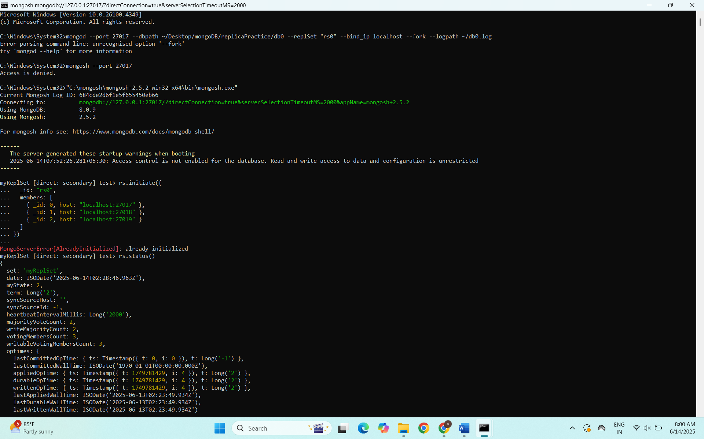

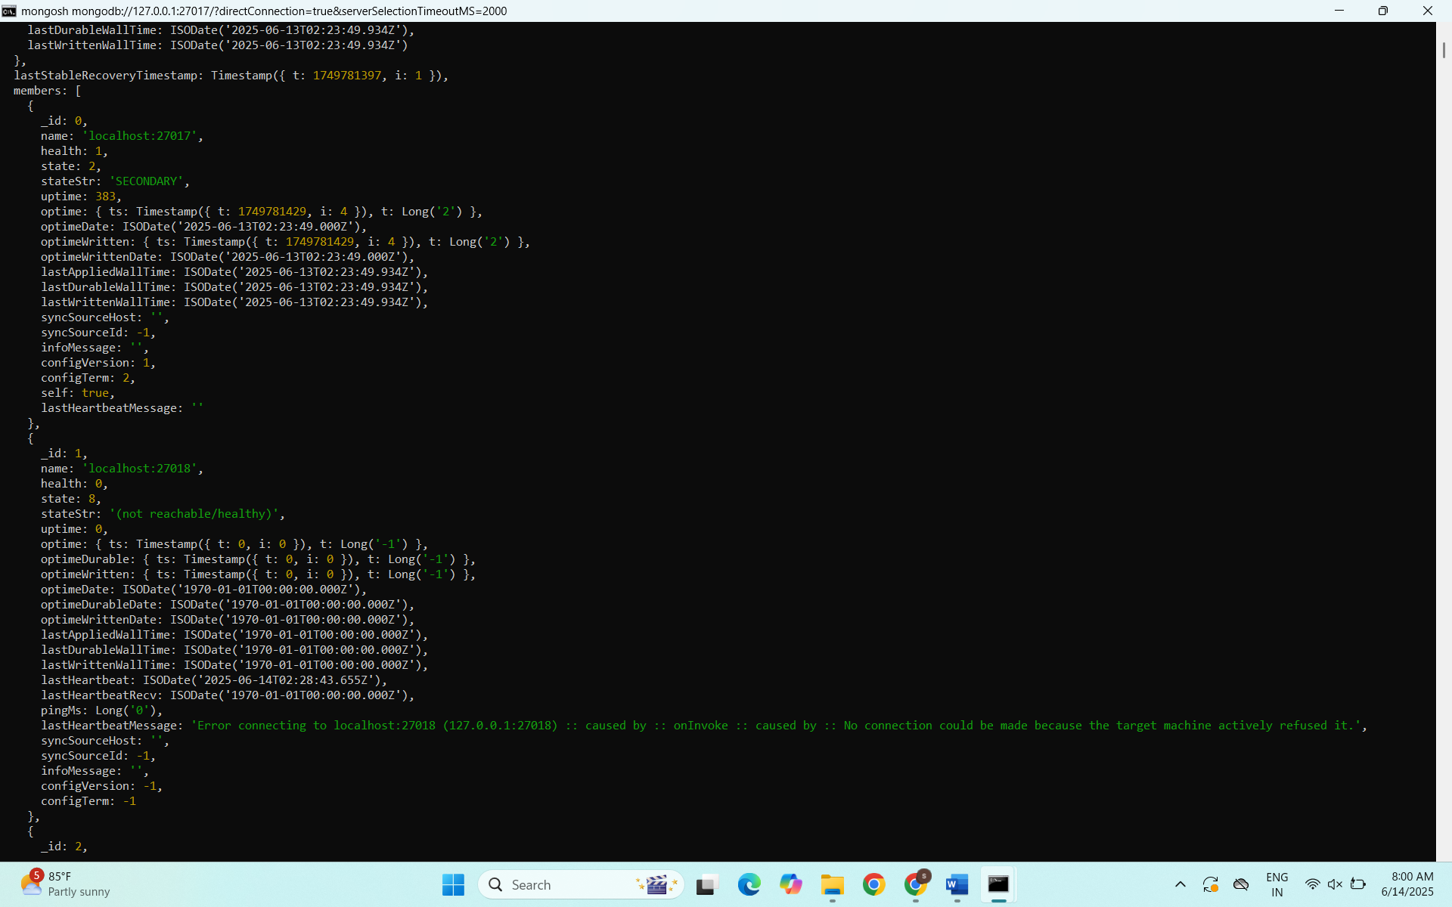

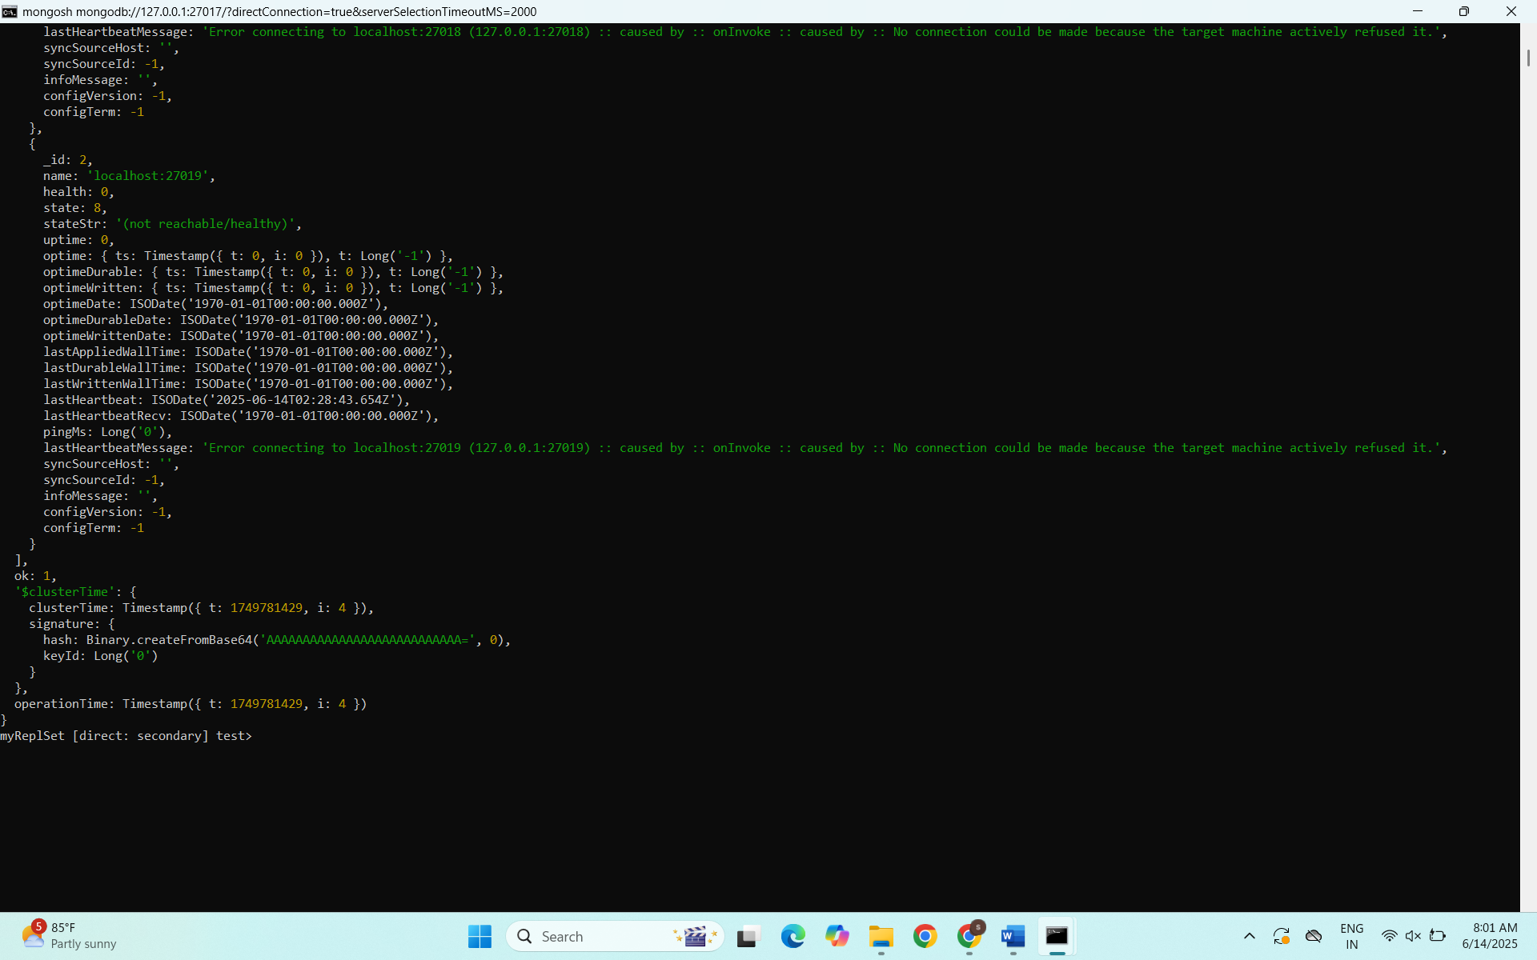

test> rs.initiate({

... _id: "myReplSet",

... members: [

... { _id: 0, host: "localhost:27017" },

... { _id: 1, host: "localhost:27018" },

... { _id: 2, host: "localhost:27019" }

... ]

... })

...

{

ok: 1,

'$clusterTime': {

clusterTime: Timestamp({ t: 1749781165, i: 1 }),

signature: {

hash: Binary.createFromBase64('AAAAAAAAAAAAAAAAAAAAAAAAAAA=', 0),

keyId: Long('0')

}

},

operationTime: Timestamp({ t: 1749781165, i: 1 })

}

myReplSet [direct: secondary] test> rs.status()

{

set: 'myReplSet',

date: ISODate('2025-06-13T02:19:48.397Z'),

myState: 1,

term: Long('1'),

syncSourceHost: '',

syncSourceId: -1,

heartbeatIntervalMillis: Long('2000'),

majorityVoteCount: 2,

writeMajorityCount: 2,

votingMembersCount: 3,

writableVotingMembersCount: 3,

optimes: {

lastCommittedOpTime: { ts: Timestamp({ t: 1749781176, i: 16 }), t: Long('1') },

lastCommittedWallTime: ISODate('2025-06-13T02:19:36.973Z'),

readConcernMajorityOpTime: { ts: Timestamp({ t: 1749781176, i: 16 }), t: Long('1') },

appliedOpTime: { ts: Timestamp({ t: 1749781176, i: 16 }), t: Long('1') },

durableOpTime: { ts: Timestamp({ t: 1749781176, i: 16 }), t: Long('1') },

writtenOpTime: { ts: Timestamp({ t: 1749781176, i: 16 }), t: Long('1') },

lastAppliedWallTime: ISODate('2025-06-13T02:19:36.973Z'),

lastDurableWallTime: ISODate('2025-06-13T02:19:36.973Z'),

lastWrittenWallTime: ISODate('2025-06-13T02:19:36.973Z')

},

lastStableRecoveryTimestamp: Timestamp({ t: 1749781165, i: 1 }),

electionCandidateMetrics: {

lastElectionReason: 'electionTimeout',

lastElectionDate: ISODate('2025-06-13T02:19:36.755Z'),

electionTerm: Long('1'),

lastCommittedOpTimeAtElection: { ts: Timestamp({ t: 1749781165, i: 1 }), t: Long('-1') },

lastSeenWrittenOpTimeAtElection: { ts: Timestamp({ t: 1749781165, i: 1 }), t: Long('-1') },

lastSeenOpTimeAtElection: { ts: Timestamp({ t: 1749781165, i: 1 }), t: Long('-1') },

numVotesNeeded: 2,

priorityAtElection: 1,

electionTimeoutMillis: Long('10000'),

numCatchUpOps: Long('0'),

newTermStartDate: ISODate('2025-06-13T02:19:36.876Z'),

wMajorityWriteAvailabilityDate: ISODate('2025-06-13T02:19:37.362Z')

},

members: [

{

_id: 0,

name: 'localhost:27017',

health: 1,

state: 1,

stateStr: 'PRIMARY',

uptime: 71,

optime: { ts: Timestamp({ t: 1749781176, i: 16 }), t: Long('1') },

optimeDate: ISODate('2025-06-13T02:19:36.000Z'),

optimeWritten: { ts: Timestamp({ t: 1749781176, i: 16 }), t: Long('1') },

optimeWrittenDate: ISODate('2025-06-13T02:19:36.000Z'),

lastAppliedWallTime: ISODate('2025-06-13T02:19:36.973Z'),

lastDurableWallTime: ISODate('2025-06-13T02:19:36.973Z'),

lastWrittenWallTime: ISODate('2025-06-13T02:19:36.973Z'),

syncSourceHost: '',

syncSourceId: -1,

infoMessage: 'Could not find member to sync from',

electionTime: Timestamp({ t: 1749781176, i: 1 }),

electionDate: ISODate('2025-06-13T02:19:36.000Z'),

configVersion: 1,

configTerm: 1,

self: true,

lastHeartbeatMessage: ''

},

{

_id: 1,

name: 'localhost:27018',

health: 1,

state: 2,

stateStr: 'SECONDARY',

uptime: 22,

optime: { ts: Timestamp({ t: 1749781176, i: 16 }), t: Long('1') },

optimeDurable: { ts: Timestamp({ t: 1749781176, i: 16 }), t: Long('1') },

optimeWritten: { ts: Timestamp({ t: 1749781176, i: 16 }), t: Long('1') },

optimeDate: ISODate('2025-06-13T02:19:36.000Z'),

optimeDurableDate: ISODate('2025-06-13T02:19:36.000Z'),

optimeWrittenDate: ISODate('2025-06-13T02:19:36.000Z'),

lastAppliedWallTime: ISODate('2025-06-13T02:19:36.973Z'),

lastDurableWallTime: ISODate('2025-06-13T02:19:36.973Z'),

lastWrittenWallTime: ISODate('2025-06-13T02:19:36.973Z'),

lastHeartbeat: ISODate('2025-06-13T02:19:46.864Z'),

lastHeartbeatRecv: ISODate('2025-06-13T02:19:47.901Z'),

pingMs: Long('0'),

lastHeartbeatMessage: '',

syncSourceHost: 'localhost:27017',

syncSourceId: 0,

infoMessage: '',

configVersion: 1,

configTerm: 1

},

{

_id: 2,

name: 'localhost:27019',

health: 1,

state: 2,

stateStr: 'SECONDARY',

uptime: 22,

optime: { ts: Timestamp({ t: 1749781176, i: 16 }), t: Long('1') },

optimeDurable: { ts: Timestamp({ t: 1749781176, i: 16 }), t: Long('1') },

optimeWritten: { ts: Timestamp({ t: 1749781176, i: 16 }), t: Long('1') },

optimeDate: ISODate('2025-06-13T02:19:36.000Z'),

optimeDurableDate: ISODate('2025-06-13T02:19:36.000Z'),

optimeWrittenDate: ISODate('2025-06-13T02:19:36.000Z'),

lastAppliedWallTime: ISODate('2025-06-13T02:19:36.973Z'),

lastDurableWallTime: ISODate('2025-06-13T02:19:36.973Z'),

lastWrittenWallTime: ISODate('2025-06-13T02:19:36.973Z'),

lastHeartbeat: ISODate('2025-06-13T02:19:46.881Z'),

lastHeartbeatRecv: ISODate('2025-06-13T02:19:47.841Z'),

pingMs: Long('0'),

lastHeartbeatMessage: '',

syncSourceHost: 'localhost:27017',

syncSourceId: 0,

infoMessage: '',

configVersion: 1,

configTerm: 1

}

],

ok: 1,

'$clusterTime': {

clusterTime: Timestamp({ t: 1749781176, i: 16 }),

signature: {

hash: Binary.createFromBase64('AAAAAAAAAAAAAAAAAAAAAAAAAAA=', 0),

keyId: Long('0')

}

},

operationTime: Timestamp({ t: 1749781176, i: 16 })

}

myReplSet [direct: primary] test>